User Guide: TAGIC KPI AGENCY CL
Procedure for KPI balance score card

Contents:
 | Page
Introduction | 4
Login Page for TAGIC | 5
TAGIC KPI System | 6
File Upload Sector | 7
Audit File | 11
Manual Mapping | 13
KPI Scoring | 16
Mapped KPI | 18
Edit Mapped KPI | 20
Generate KPI Score | 21
KPI Score | 24
User | 27

List OF Figures
 | Page
Figure 1: Login Page | 5
Figure 2: Login Page Settings | 5
Figure 3: TAGIC Dashboard | 6
Figure 4: File Upload Sector | 7
Figure 5: File Upload Page | 8
Figure 6: Delete Request Details | 9
Figure 7: Uploaded File Details | 10
Figure 8: Audit File | 11
Figure 9: Audit File Action | 11
Figure 10: Audit File Process | 12
Figure 11: Audit File Approved | 12
Figure 12: Manual Mapping Page | 13
Figure 13: Manual Mapping HPM | 14
Figure 14: Manual Mapping Area | 14
Figure 15: Manual Mapping Key | 15
Figure 16: Map KPI | 16
Figure 17: Map KPI Replicate | 16
Figure 18: KPI Rule Replication | 17
Figure 19: Mapped KPI Details: Area | 18
Figure 20: Mapped KPI Details: HPM | 19
Figure 21: Mapped KPI Details: Key | 19
Figure 22: Edit Mapped KPI | 20
Figure 23: Generate KPI Score Monthly | 21
Figure 24: Generate KPI Score Quarterly | 22
Figure 25: Generate KPI Score YTD | 23
Figure 26: View KPI Score Area | 24
Figure 27: View KPI Score HPM | 24
Figure 28: View KPI Score Key | 25
Figure 29: View KPI Score in Details | 25
Figure 30: Excel KPI Score | 26
Figure 31: KPI User | 27
Figure 32: Add User | 27
Figure 33: Edit User | 28
Figure 34: Edit/Update User | 28

Introduction:
TAGIC KPI software is a powerful reporting tool specifically developed for businesses aiming to monitor and analyze key performance indicators (KPIs) that are directly aligned with their unique business goals and objectives. One of its key applications is in calculating score and commissions for sales employees based on their monthly, quarterly, yearly performance, utilizing the balanced scorecard format. By utilizing TAGIC KPI software, businesses can effectively track their progress, gain valuable insights, and drive sustainable growth, ultimately leading to increased profitability.
The software is designed to provide a user-friendly experience, ensuring that even with its inherent complexity, users can easily navigate and utilize its various features. It streamlines the process of KPI mapping, score generation, and data dump upload, making it an efficient and comprehensive solution for businesses seeking to optimize their performance tracking and analysis.
There are 4 types of users:
Type | Name
Level 1 | Data Upload Manager
Level 2 | Approval Manager
Level 3 | Business User
Level 4 | Admin User

Each user type has specific roles and responsibilities within the system. The Data Upload Manager is responsible for uploading and managing data, the Approval Manager oversees the approval process, the Business User utilizes the system for viewing the score, and the Admin User has administrative privileges and controls system settings and user management.

These user types represent different levels of access and permissions within the system, ensuring that each user has the appropriate level of authority and functionality based on their role and responsibilities.

The URL for the TAGIC KPI is: http://10.33.195.171/tagic_kpi/#/

Login Page for TAGIC:
This is the login page of Tata AIG KPI Product. You will need to enter the NTID username and password of the system to log into the product.
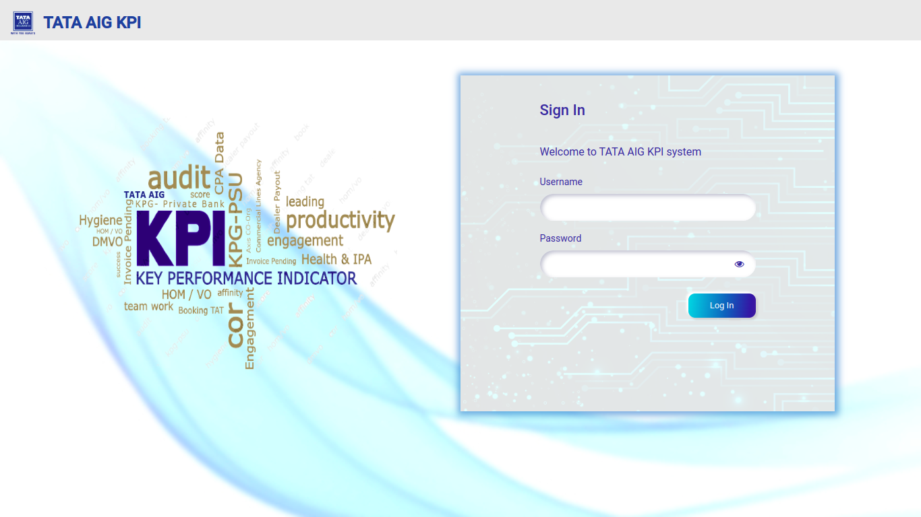
Figure 1: Login Page
Once you log in to the system, the page will open as shown below [Figure 2]. You can select your channel=”Agency CL” and month & Year.
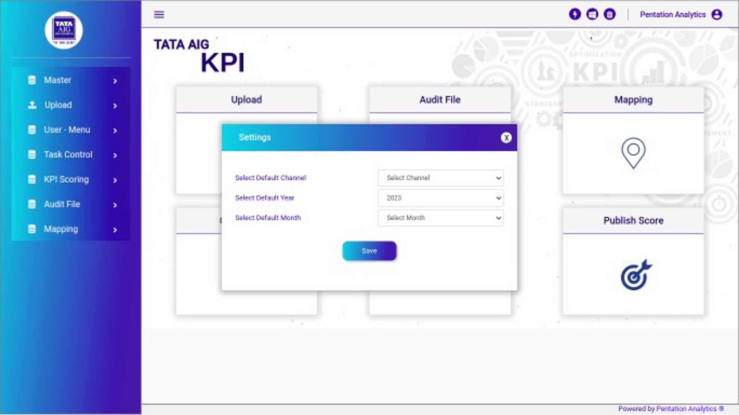
Figure 2: Login Page Settings

TATA AIG KPI System:
There are 5 steps to calculate the final score:
- Upload
- Audit File
- Mapping
- Calculation
- Generate Score
- Publish Score
Upload: Users can upload all files from this location.
Audit File: Admins can use the Audit file. The uploaded file will be reviewed and approved by the admin through the action. The admin can also view the data of the uploaded file. If the data is not correctly uploaded, the admin has the option to reject it.
Mapping: User/Admin can map each file individually.
Calculation: Admins can set the weightage from clicking on calculation
Generate Score: Once the mapping is completed, User can generate the score within minutes.
Publish Score: Admins and users can view the score. It will display all employees with their Rank who have achieved the maximum score.
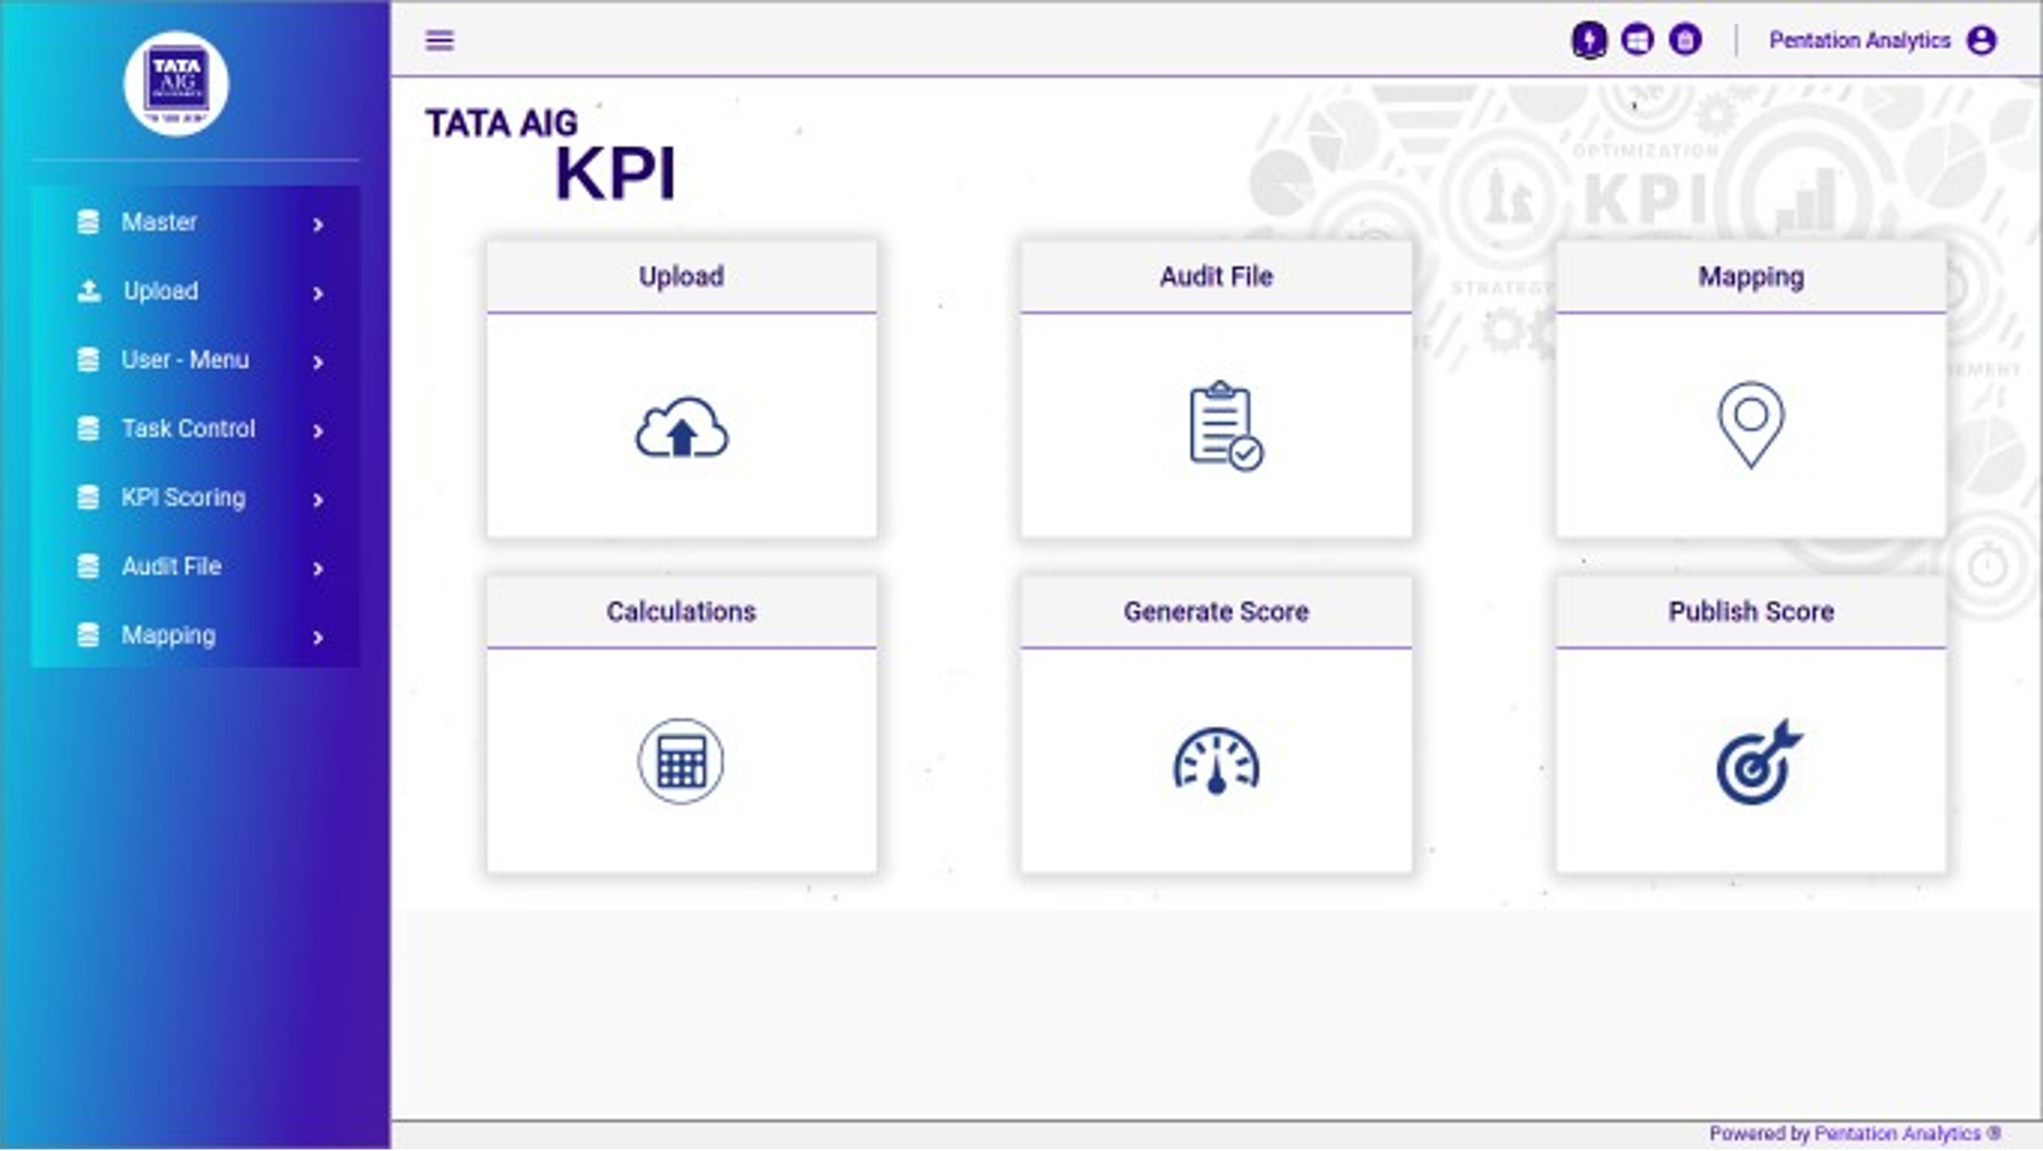
Figure 3: TAGIC Dashboard

File Upload Sector:
Once the user clicks on the upload button, they will be redirected to the file upload sector page, where they can view the channel name and file type. If the user selects “Agency CL” channel, File type will display the corresponding channel's file name.
Once the user selects the respective file name and clicks on the "Go to Page" button, they will be redirected to the file upload page. From there, they can proceed to upload the file.
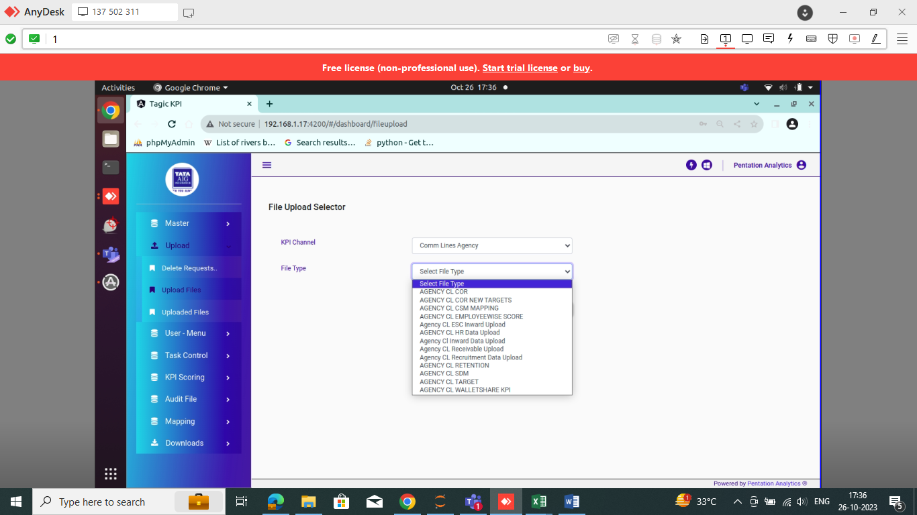
Figure 4: File Upload Sector
For example, if the user selects the Agency CL channel, in file type all file names are reflecting which is important in Agency CL. For example, User chooses the Agency CL Target file type, and then clicks on the "Go to Page" button from file upload sector, it will be redirected to the following page (Figure 5). On this page, the user can upload the file or drag and drop it to the respective month. Users have the option to upload CSV and Excel files.
If the user wants to upload data for two or three months, they can select the "Add to Existing" button and upload the same file from there. This allows them to upload the file once and associate it with multiple months of data.
If the user is unsure about which template to use for uploading the file, they can download the template from “Download Template” button.
Users need to ensure that they handle certain validations while uploading files. If a user uploads a file with null or blank values, an error message will be displayed on the page. In such cases, the user can download the error file to check where the incorrect data is located. Additionally, it is important for the user to follow the "yyyy-mm-dd" date format for csv file, as any deviation from this format will result in an error. If any % available in file it will give error as well.
While uploading the data please check the data of the file which is available in your format. Once data is uploading successfully it will show that file is uploaded successfully.
Files Uploaded in Agency CL Channel are as below:
File Name:
AGENCY CL COR
AGENCY CL COR New Target
AGENCY CL Employee Score
AGENCY CL HR Data Upload
AGENCY CL Inward Data Upload
AGENCY CL CSM Mapping
AGENCY CL ESC Inward Upload
AGENCY CL Retention
AGENCY CL Recruitment Data Upload
AGENCY CL Target
AGENCY CL Receivable Upload
AGENCY CL SDM
AGENCY CL WALLETSHARE KPI

After uploading the data successfully the page is shown as below SS:
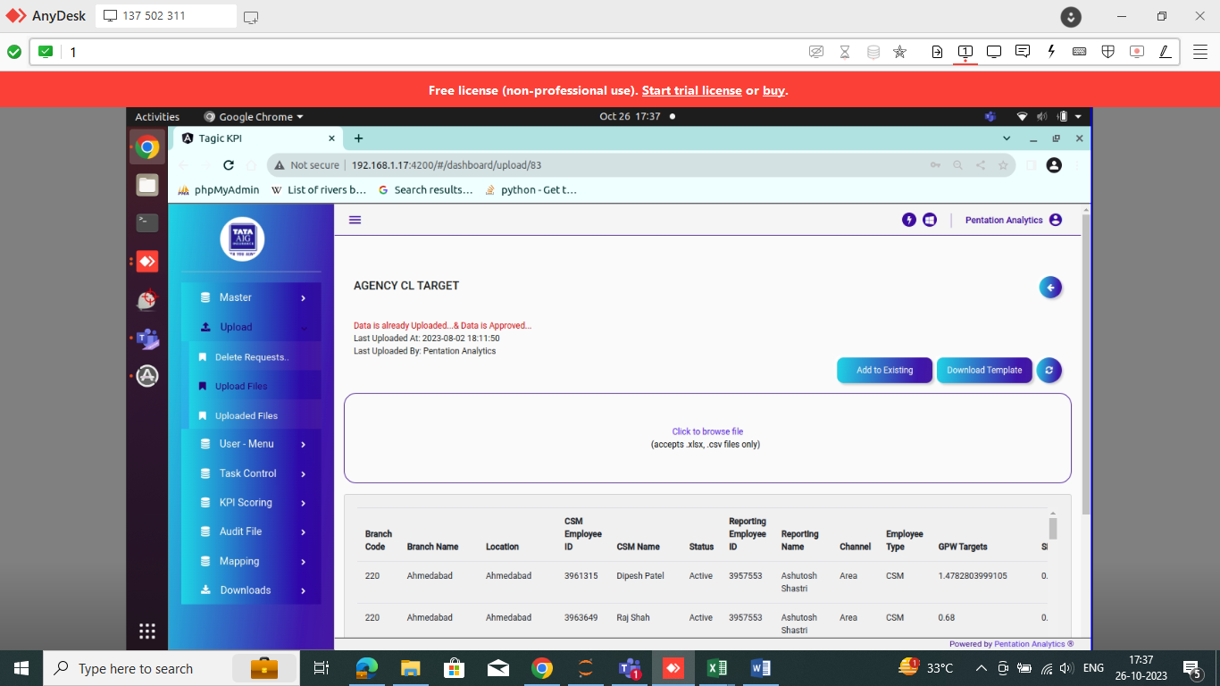
Figure 5: File Upload Page
Delete Request Details:
If the data is found to be inaccurate or incomplete, the admin can reject/delete it by selecting the cross symbol via the eye button.

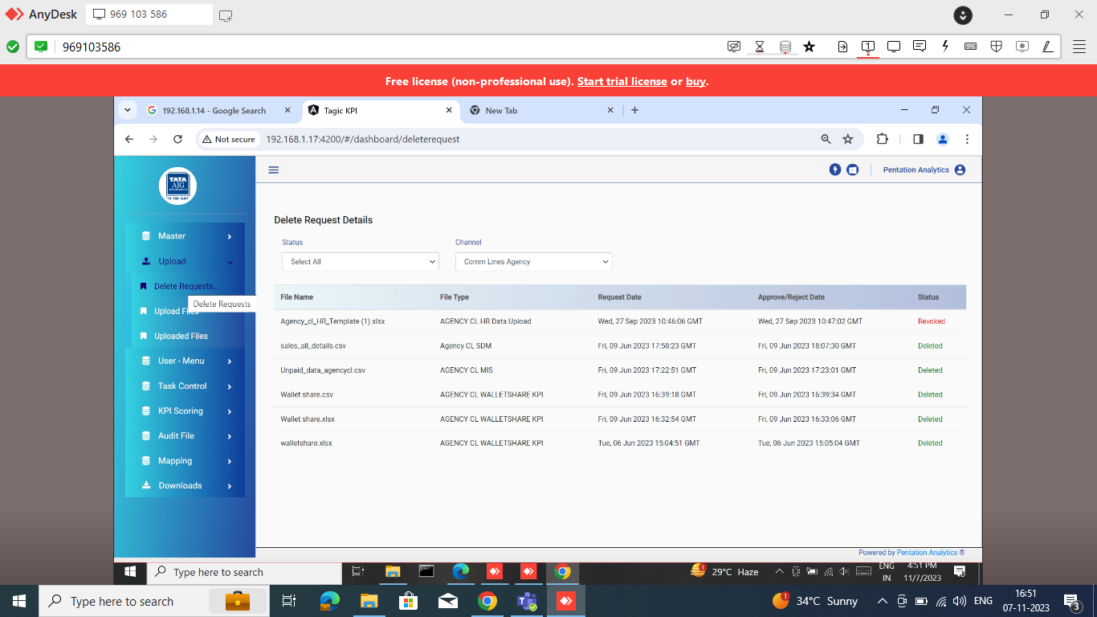
Figure 6: Delete request details

Uploaded File:
In Uploaded File Details, the admin/user can see which User Upload and approved the file and the corresponding date. If, for some reason, a file fails to upload successfully, it will be indicated in the status column with "Failed". If the file is uploaded successfully, it will be indicated in the status column with "Uploaded". If the file is uploaded successfully and approved, it by Admin it will be indicated in the status column with "Approved".
When the data is uploaded by the user, the User can view the data and also download the data. If the data is uploaded accurately than, the admin can approve it by selecting the thumb symbol through the eye button. This action confirms that the data has been thoroughly reviewed and approved. However, if the data is found to be inaccurate or incomplete, the admin can reject it by selecting the cross symbol via the eye button.

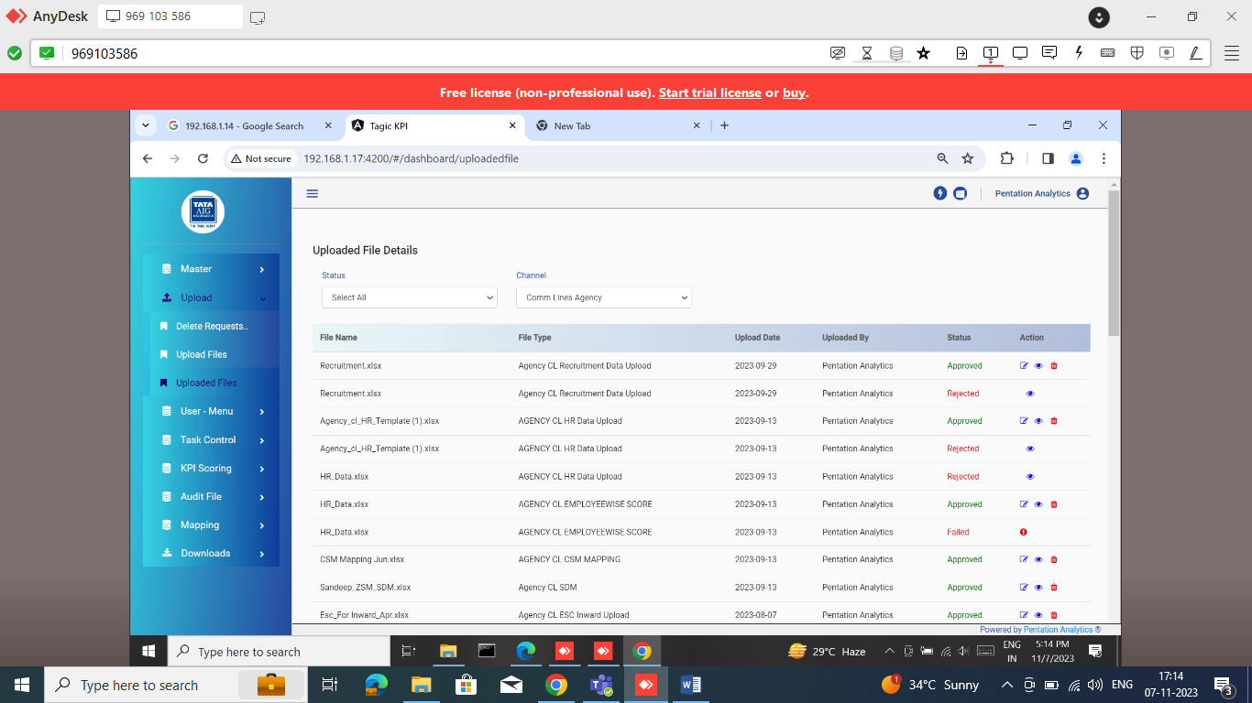

Figure 7: Uploaded File Details

Audit File:
Admin users have access to the Audit file, where they can review and approve uploaded files using the available actions. The admin can view the file name, the user who uploaded it, and the upload date. By clicking on the eye button in the action column, the admin can examine the data within the uploaded file and download it.
Additionally, the admin can see which User Upload and approved the file and the corresponding date. If, for some reason, a file fails to upload successfully, it will be indicated in the status column with "Failed". If the file is uploaded successfully, it will be indicated in the status column with "Uploaded". If the file is uploaded successfully and approved, it by Admin it will be indicated in the status column with "Approved".
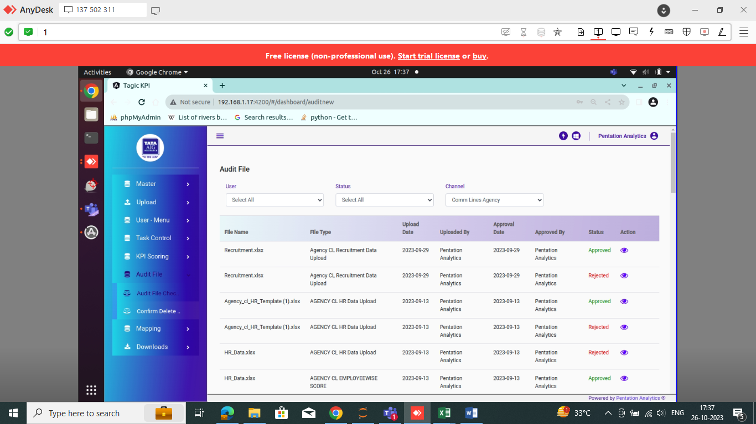
Figure 8: Audit File
When the data is uploaded by the user, the admin can view the data and also download the data. If the data is uploaded accurately than, the admin can approve it by selecting the thumb symbol through the eye button. This action confirms that the data has been thoroughly reviewed and approved. However, if the data is found to be inaccurate or incomplete, the admin can reject it by selecting the cross symbol via the eye button.
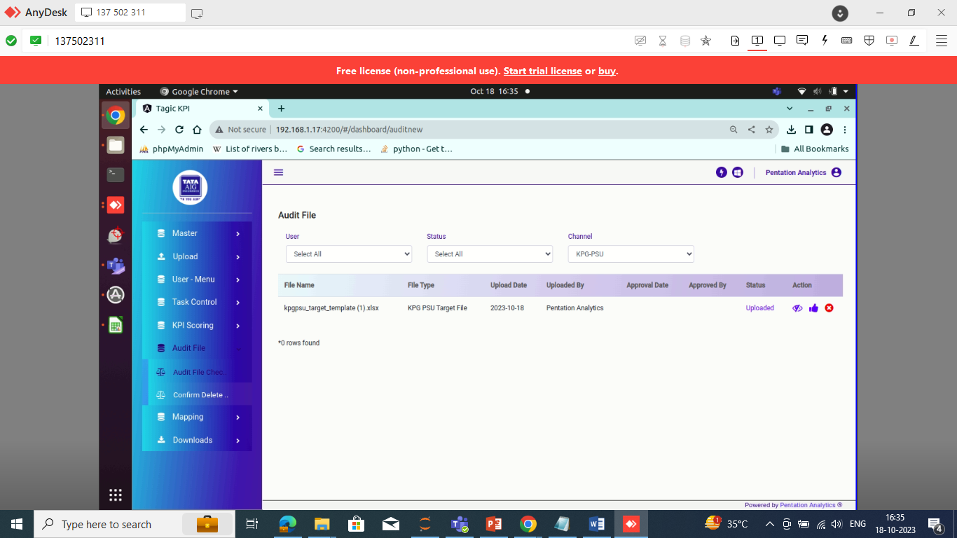
Figure 9: Audit File Action
If the admin selects the "Reject" button, they will receive a confirmation asking if they really want to reject the file. If the admin clicks "Yes," then the status will be updated to "Rejected." (Figure 7 (3)) And file will delete
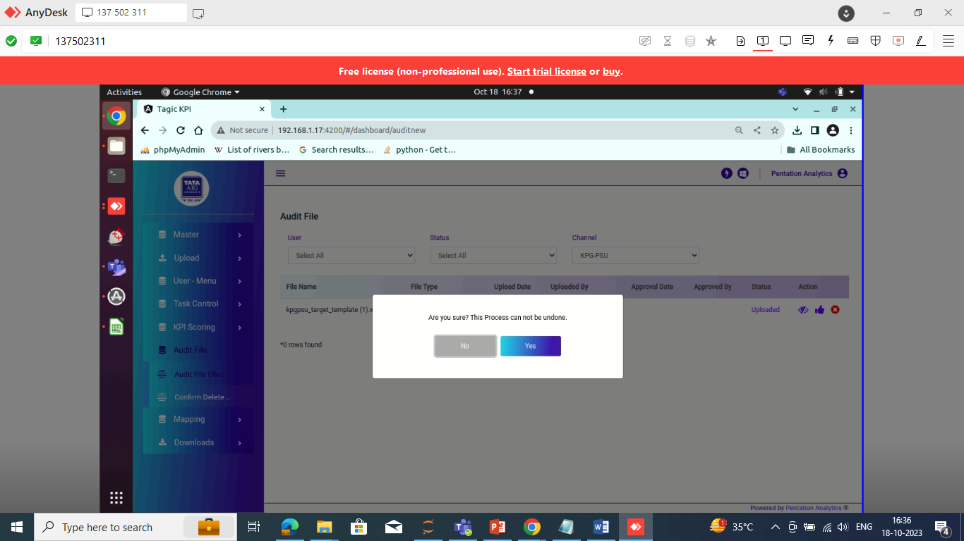
Figure 10: Audit File Process
By leveraging these actions, admins can effectively manage and verify uploaded files, ensuring the overall integrity and accuracy of the data within the system.
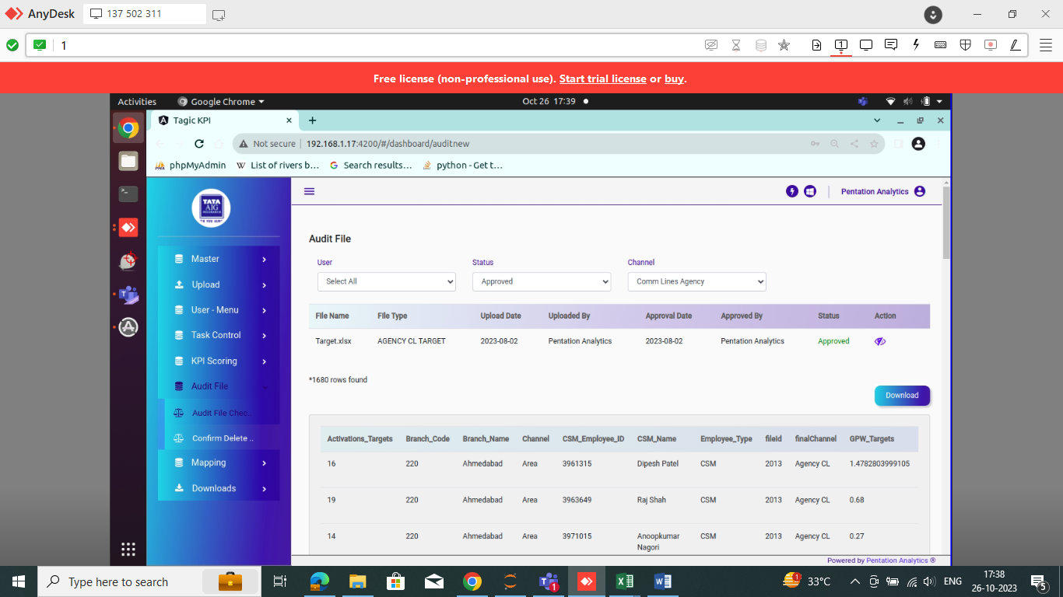
Figure 11: Audit File Approved

Manual Mapping:
During the manual mapping process, the responsibility lies with the Uploading User. The user has the ability to select the KPI year, month, Channel, Sub channel, and Vertical. Based on these selections, the system will display the respective channels' mapping file names that need to be mapped for the particular channel.
By providing the necessary input, such as the KPI year, month, Channel, Sub channel, and Vertical, the user will be able to access the specific mapping file associated with the chosen channel. This facilitates the mapping process by ensuring that the correct mapping file is used for each channel, allowing for accurate data alignment and analysis.
It is important for the user to select the appropriate mapping file for the designated channel to ensure the integrity and reliability of the mapping process. Mapping can indeed take some time, especially when there is a significant amount of data to be mapped.
For AGENCY CL Channel, there are manual mapping files are available for three verticals which are HPM, Area and Key.
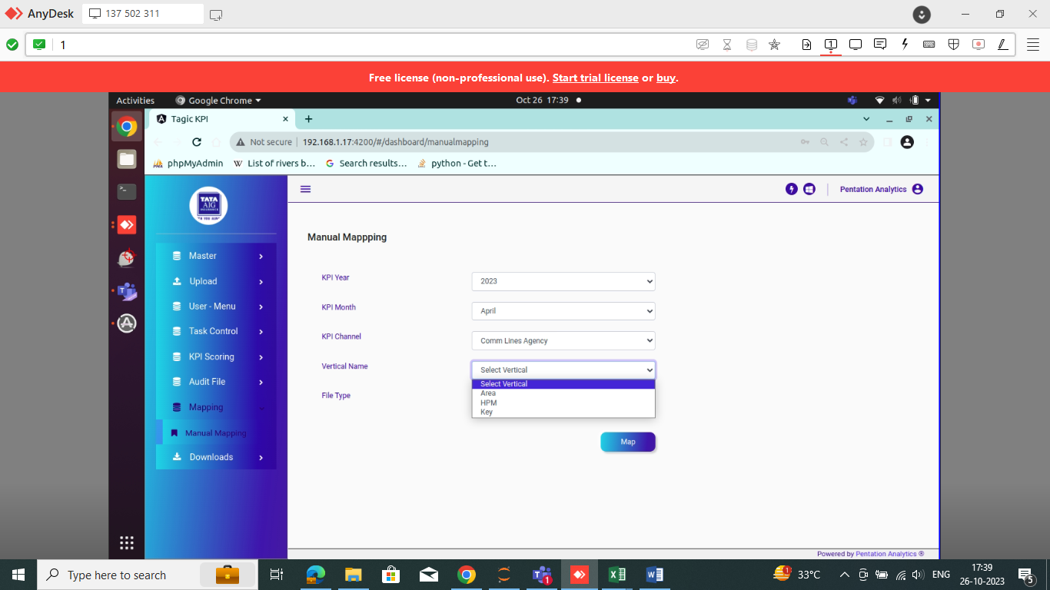
Figure 12: Manual Mapping Page
For AGENCY CL Channel and Vertical name HPM, there are 5 files available for manual mapping: Agency CL SDM, Agency CL Retention, Agency CL Recruitment, Agency CL Receivable, Agency CL Inward, and Agency CL ESC Inward.
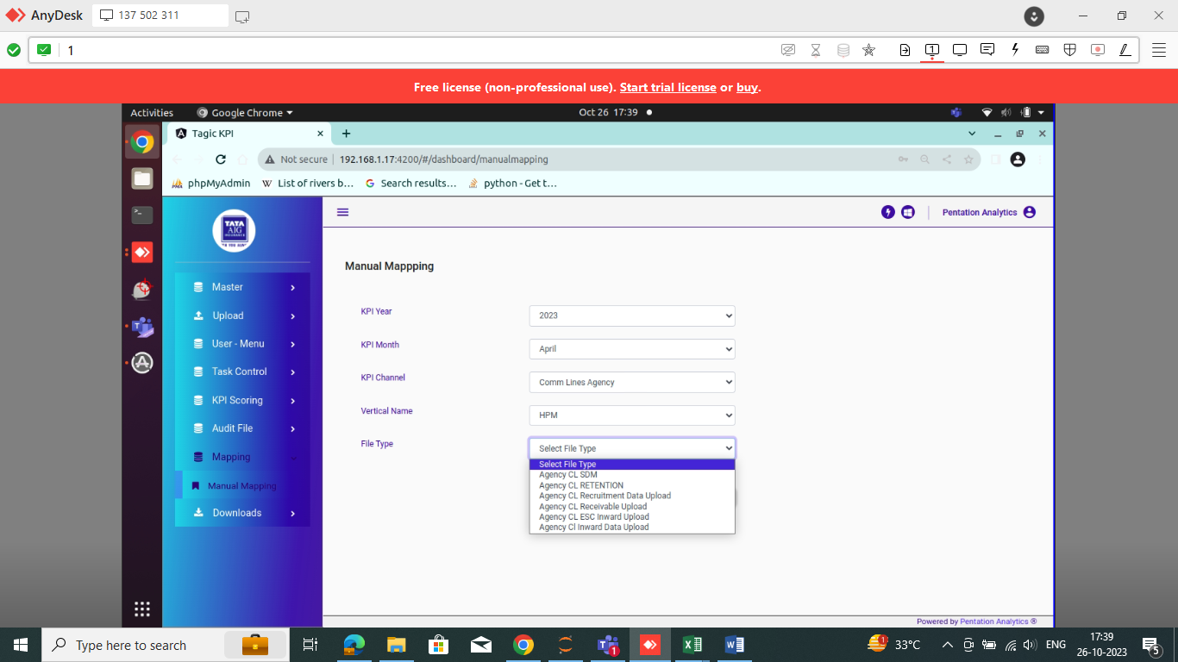
Figure 13: Manual Mapping HPM
For AGENCY CL Channel and Vertical name Area, there are 5 files available for manual mapping: Agency CL SDM, Agency CL Retention, Agency CL Recruitment, Agency CL Receivable, Agency CL Inward, and Agency CL ESC Inward.
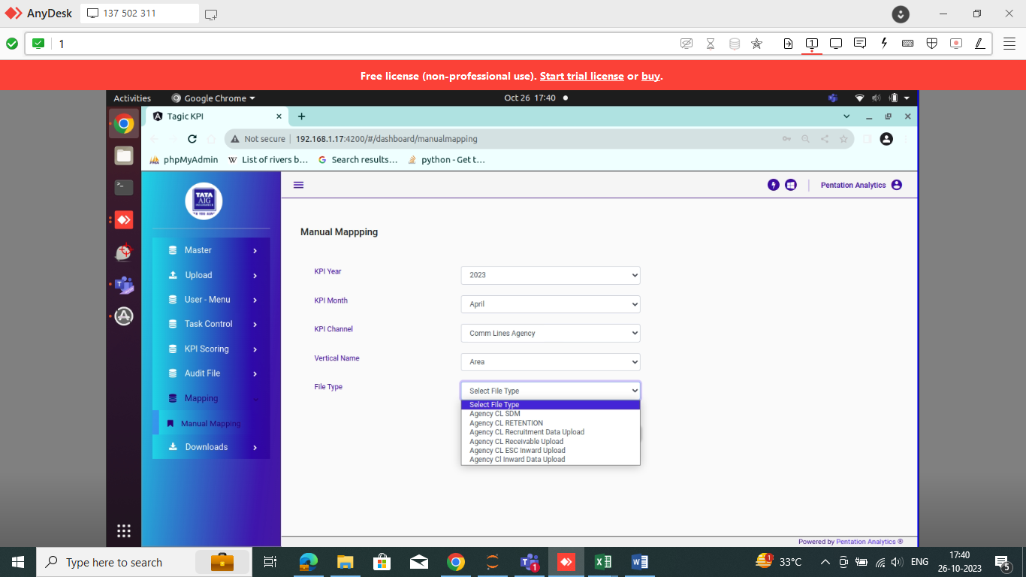
Figure 14: Manual Mapping Area
For AGENCY CL Channel and Vertical name Key, there are 5 files available for manual mapping: Agency CL SDM, Agency CL Retention, Agency CL Recruitment, Agency CL Receivable, Agency CL Inward, and Agency CL ESC Inward.

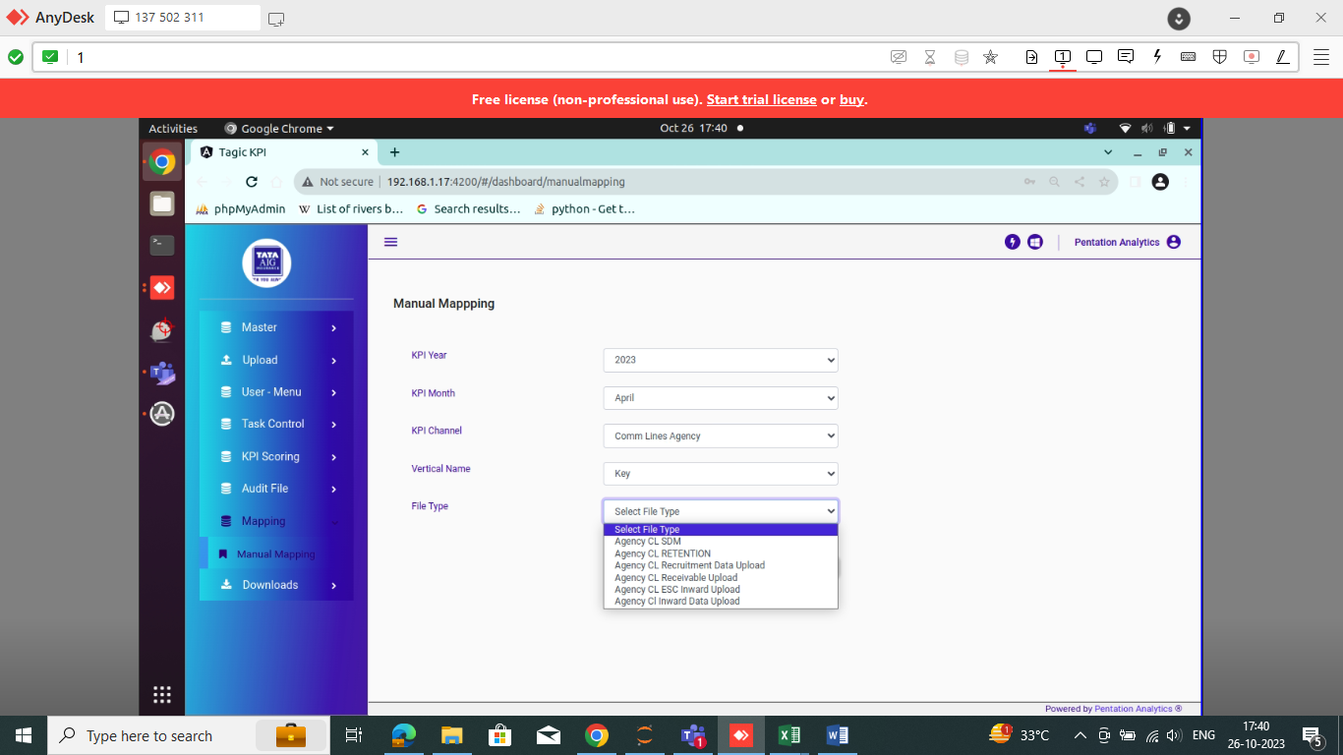
Figure 15: Manual Mapping Key

KPI Scoring:

KPI Mapping:
KPI Mapping is used to set the KPI parameter weightage. Here, the user needs to add details in the following fields: Channel Name, Vertical Name, Role, KPI Month, KPI Year, KPI Parameter Channel, Base Parameter, Minimum Value, Maximum Value, Score Under the Range, Score Within the Range, Score Above the Range, Score Under the Range (Number), Score Within the Range (Number), Score Above the Range (Number), and Weightage. If the parameter has no weightage and the score is directly obtained from the file, there's no need to click on "Apply Weightage."
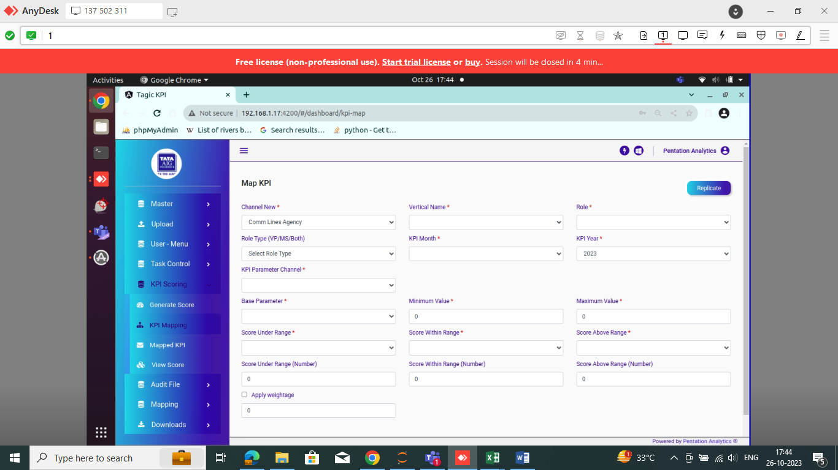
Figure 16: Map KPI

If a user wants to copy the weightage from the previous month to the current month, they should click on the "Replicate" button located in the upper right corner.
Figure 17: Map KPI Replicate

If User clicks on Replicate Button the page will redirect as shown in below figure:
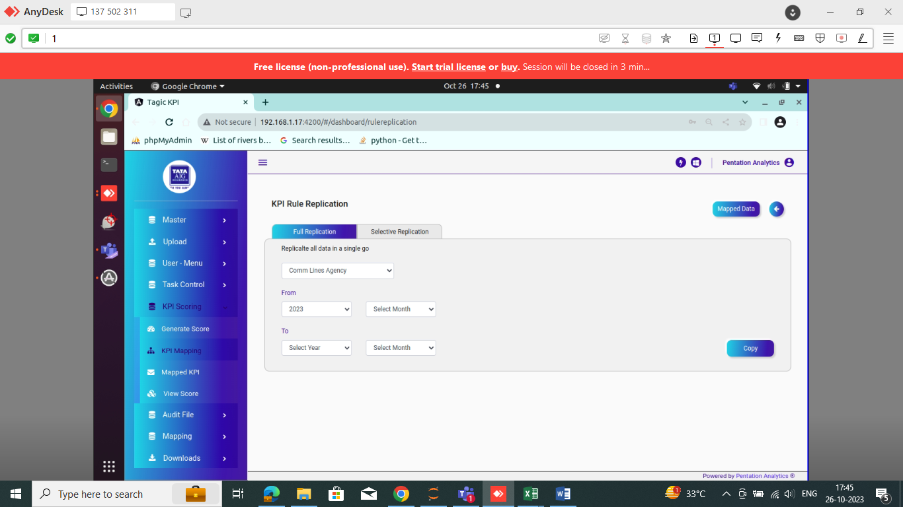
Figure 18: KPI Rule Replication

Here, first select the Channel. Then, in the "From" field, select the previous month (from which you want to copy the weightage). In the "To" field, select the current month (your KPI month), and click on "Copy". You can see the KPI Month weightage in the "Mapped KPI". If User Click on Mapped data it will redirected to Mapped KPI.

For reference, we have attached the parameter setup for AGENCY CL Area Vertical for the month of April in the table below excel file:
For reference, we have attached the parameter setup for AGENCY CL Key Vertical for the month of April in the table below excel file:
For reference, we have attached the parameter setup for AGENCY CL HPM Vertical for the month of April in the table below excel file:

Mapped KPI:
The mapped KPI are dependent on the user's role, channel, sub-channel, and month. If there are any changes to the KPI target value for a specific month, the system will update it accordingly.
In addition to updates, the system also provides a delete option in the action column. This allows users to remove or delete specific mapped KPIs if needed. The delete option offers flexibility in managing and maintaining the accuracy of the mapped KPIs. If User wants to edit the existing KPI weightage, click on edit button which is available on action.

For the AGENCY CL Channel, parameter setup are available as below S.S:
- Channel: AGENCY CL
- Vertical: Area, HPM, Key
- Role: CSM, ASM, RSM, ZSM
- Parameter: Activation, GPW, Retention, SME Target, Hygiene Receivable, Employee Attrition, COR, Training, Power Recruitment, Hygiene Inward

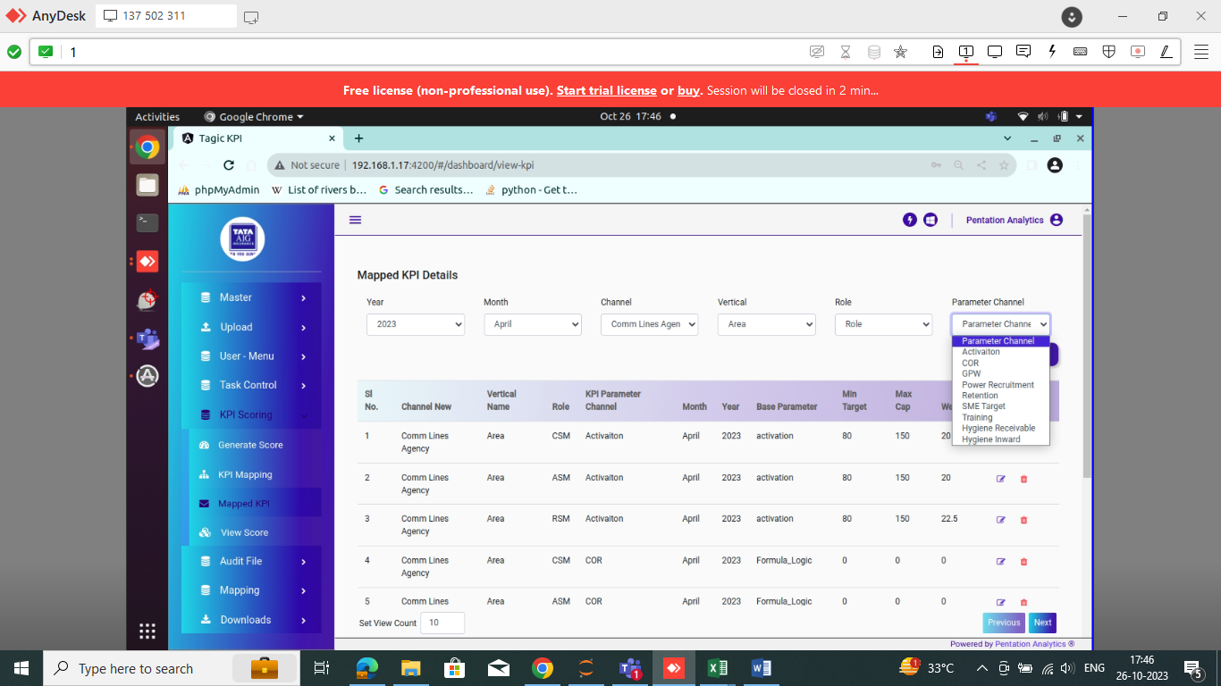
Figure 19: Mapped KPI Details: Area

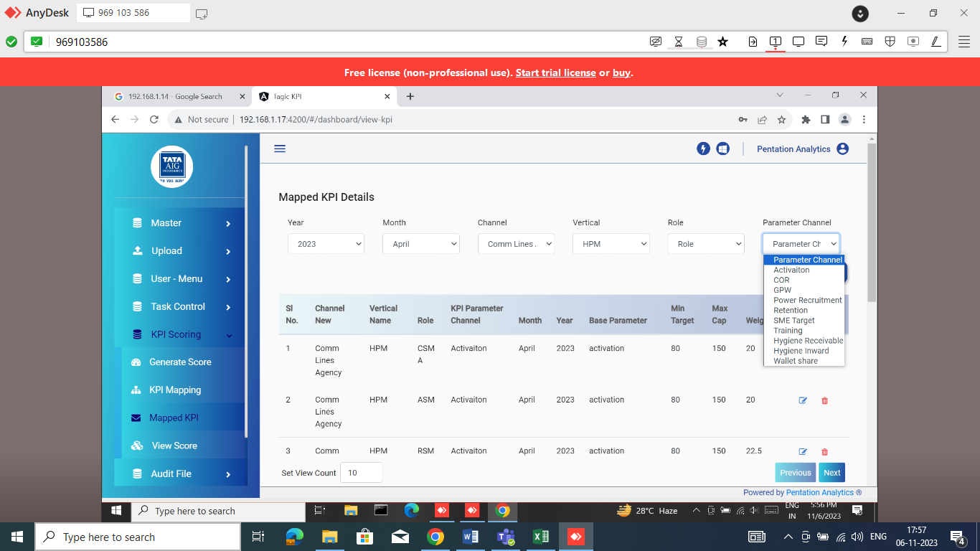
Figure 20: Mapped KPI Details: HPM

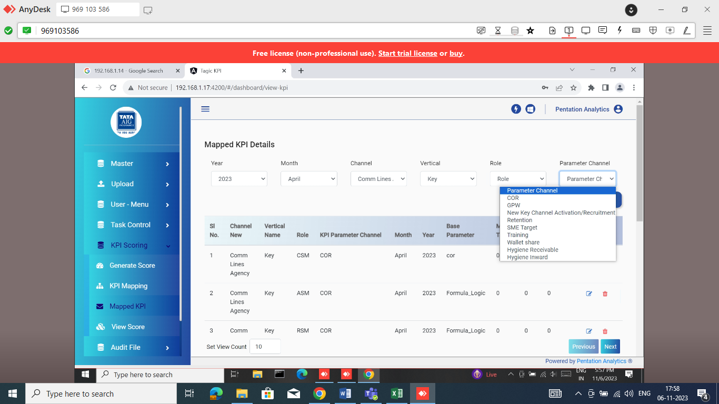
Figure 21: Mapped KPI Details: Key

Edit KPI Mapped:
Edit KPI Mapped is a feature used to establish performance targets for employees monthly. Admin has the authority to modify or define these mappings. The targets are determined based on the employee's designation, the specific month and year, as well as the channel they are associated with.
Admin can select the relevant role, month, year, channel, and sub-channel within the system. They can then set the minimum and maximum target values for the chosen parameters. Additionally, they can assign preferred, non-preferred, and moderate scores to indicate the performance levels associated with the target range.
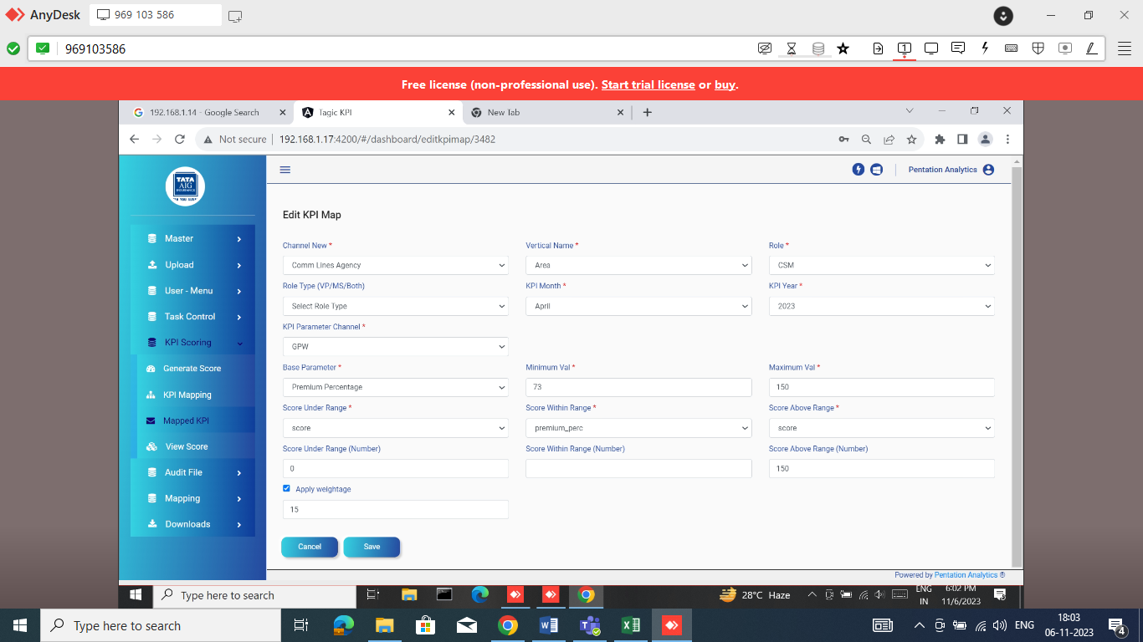
Figure 22: Edit Mapped KPI

Generate KPI Score:
Once all files are uploaded, approved and successfully mapped, the system will generate a score based on the selected year and month. Users can choose the desired year and month for which they want to generate the score.
For the monthly calculation, users have the option to select the Channel Name, Year Month, and Employee Name. Once these selections are made, they can proceed to click on the "Generate Score" button.
For the Quarterly calculation, users have the option to select the Channel Name, Year Quarter, and Employee Name. In the case of quarterly calculations, there is no need to upload all the files again. Once the initial files have been uploaded and mapped successfully, they can be retained for subsequent calculations within the same quarter. Once these selections are made, they can proceed to click on the "Generate Score" button.
By choosing the specific Channel Name, Year Month, and Employee Name, the system will calculate the performance score for the selected employee within the given time frame. The score is based on various factors, such as the employee's targets, achievements, and any other relevant metrics associated with the chosen channel.
Monthly Score Generation:
AGENCY CL:
- Channel name: AGENCY CL
- Period: Monthly
- Year:2023 ( for example)
- Month: April (for example)
- Employee Name: if wants to generate single employee score
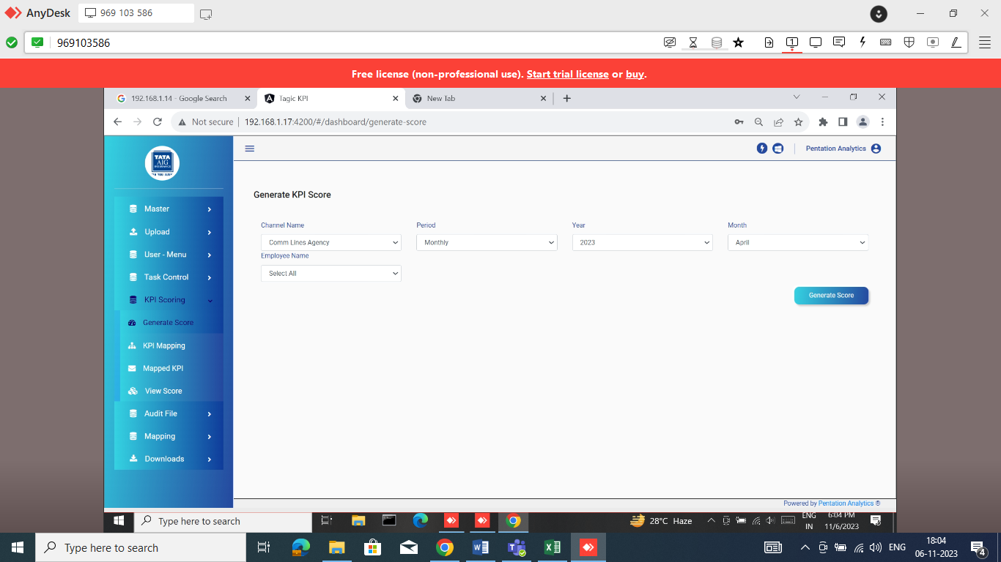
Figure 23: Generate KPI Score Monthly

Quarterly Score Generation:
AGENCY CL:
- Channel name: AGENCY CL
- Period: Quarterly
- Financial Year:2023 ( for example)
- Quarter: Q1 (for example)
- Employee Name: if wants to generate single employee score
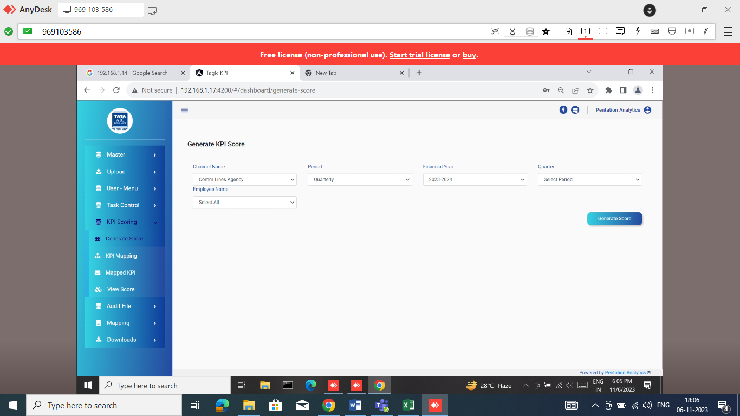
Figure 24: Generate KPI Score Quarterly

YTD Score Generation
Agency CL:
- Channel name: AGENCY CL
- Period: Year to Date
- Financial Year:2023-2024 ( for example)
- Up to Month: October (for example)
- Employee Name: if wants to generate single employee score
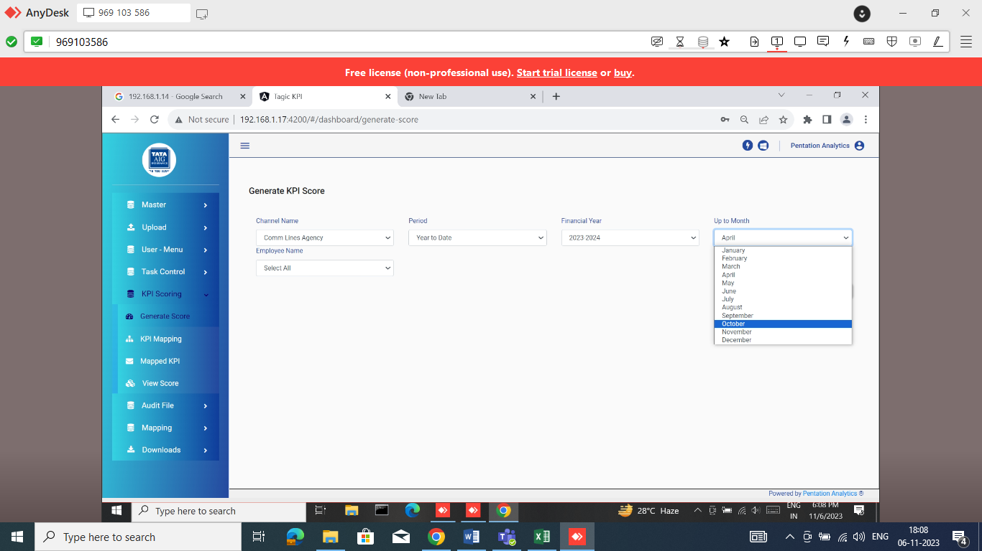
Figure 25: Generate KPI Score YTD

KPI Score:
Admin has the capability to view the scores of all employees. The system provides a feature that displays the employees who are achieving the maximum score, without a specific limitation on the number of employees shown. User can Search the Employee code/Name, Channel, Designation month etc.
AGENCY CL:
- Channel name: AGENCY CL
- Vertical: Area

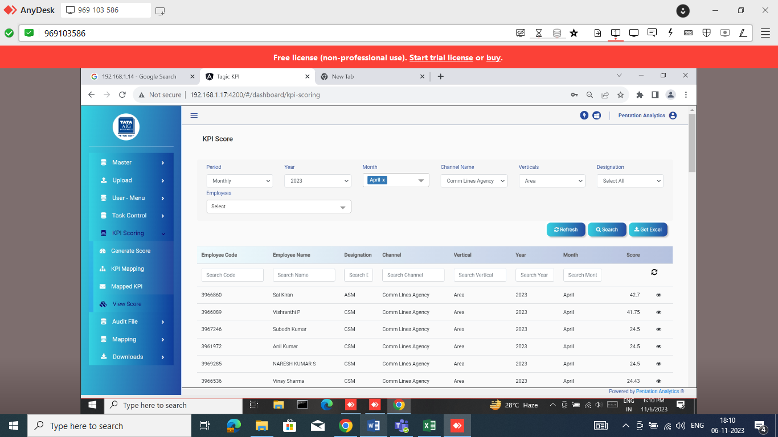
Figure 26: View KPI Score Area
- Channel name: AGENCY CL
- Vertical: HPM
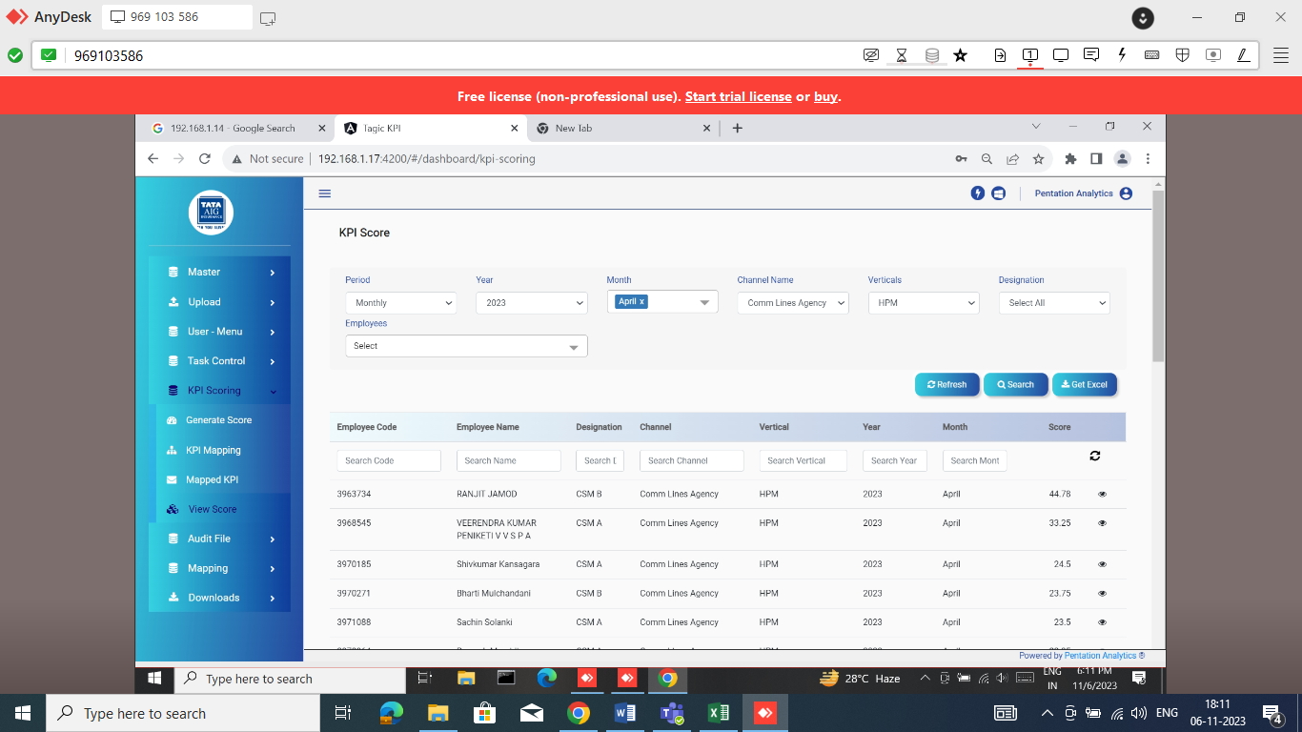
Figure 27: View KPI Score HPM

AGENCY CL:
- Channel name: AGENCY CL
- Vertical: Key
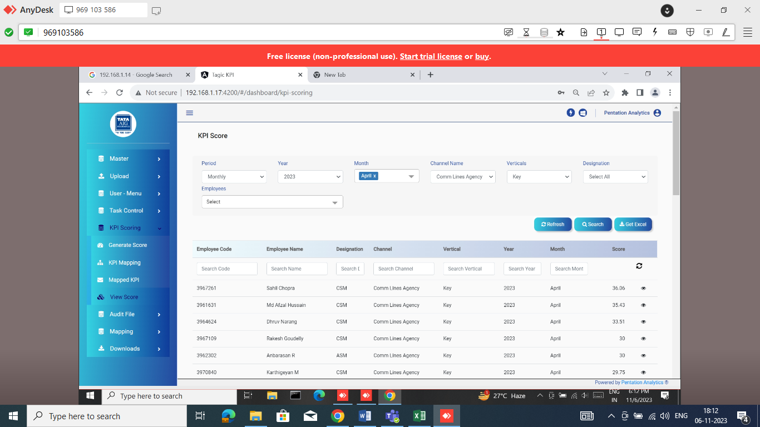
Figure 28: View KPI Score Key
If a user wants to see the scores of a specific employee across all parameters, they can search for that employee's name in the system. Once they locate the employee, they can click on the eye button to access the detailed scores for each parameter.
By initiating a search for the employee's name, the system will filter the results to display the specific employee's information. Clicking on the eye button allows the user to view the scores in detail for each parameter associated with that employee.
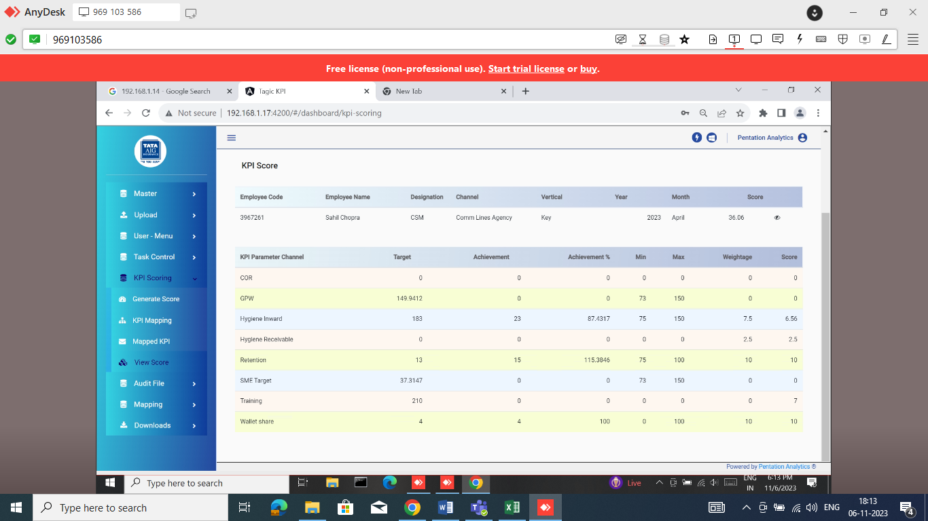
Figure 29: View KPI Score in Detail
If a user wants to download the scores of all employees, they can click on the "Get Excel" button. This action will generate an Excel file containing the score data for all employees. The Excel file will include information such as employee names, corresponding scores, and any other relevant details.
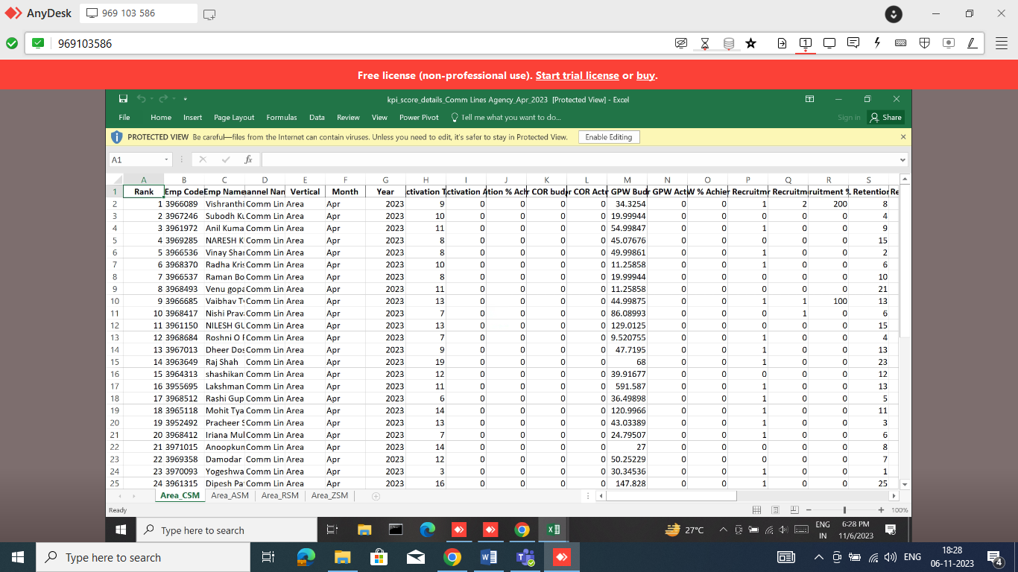
Figure 30: Excel KPI Score

User:
Admin users have the capability to create and edit user accounts from within the system. They can access a specific section or functionality that allows them to manage user accounts. This feature empowers admin users to have full control over user management within the system. They can create new accounts for new employees, make updates for existing users, or deactivate accounts when needed. By efficiently managing user accounts, admin users ensure that the system remains secure and accessible to authorized individuals.
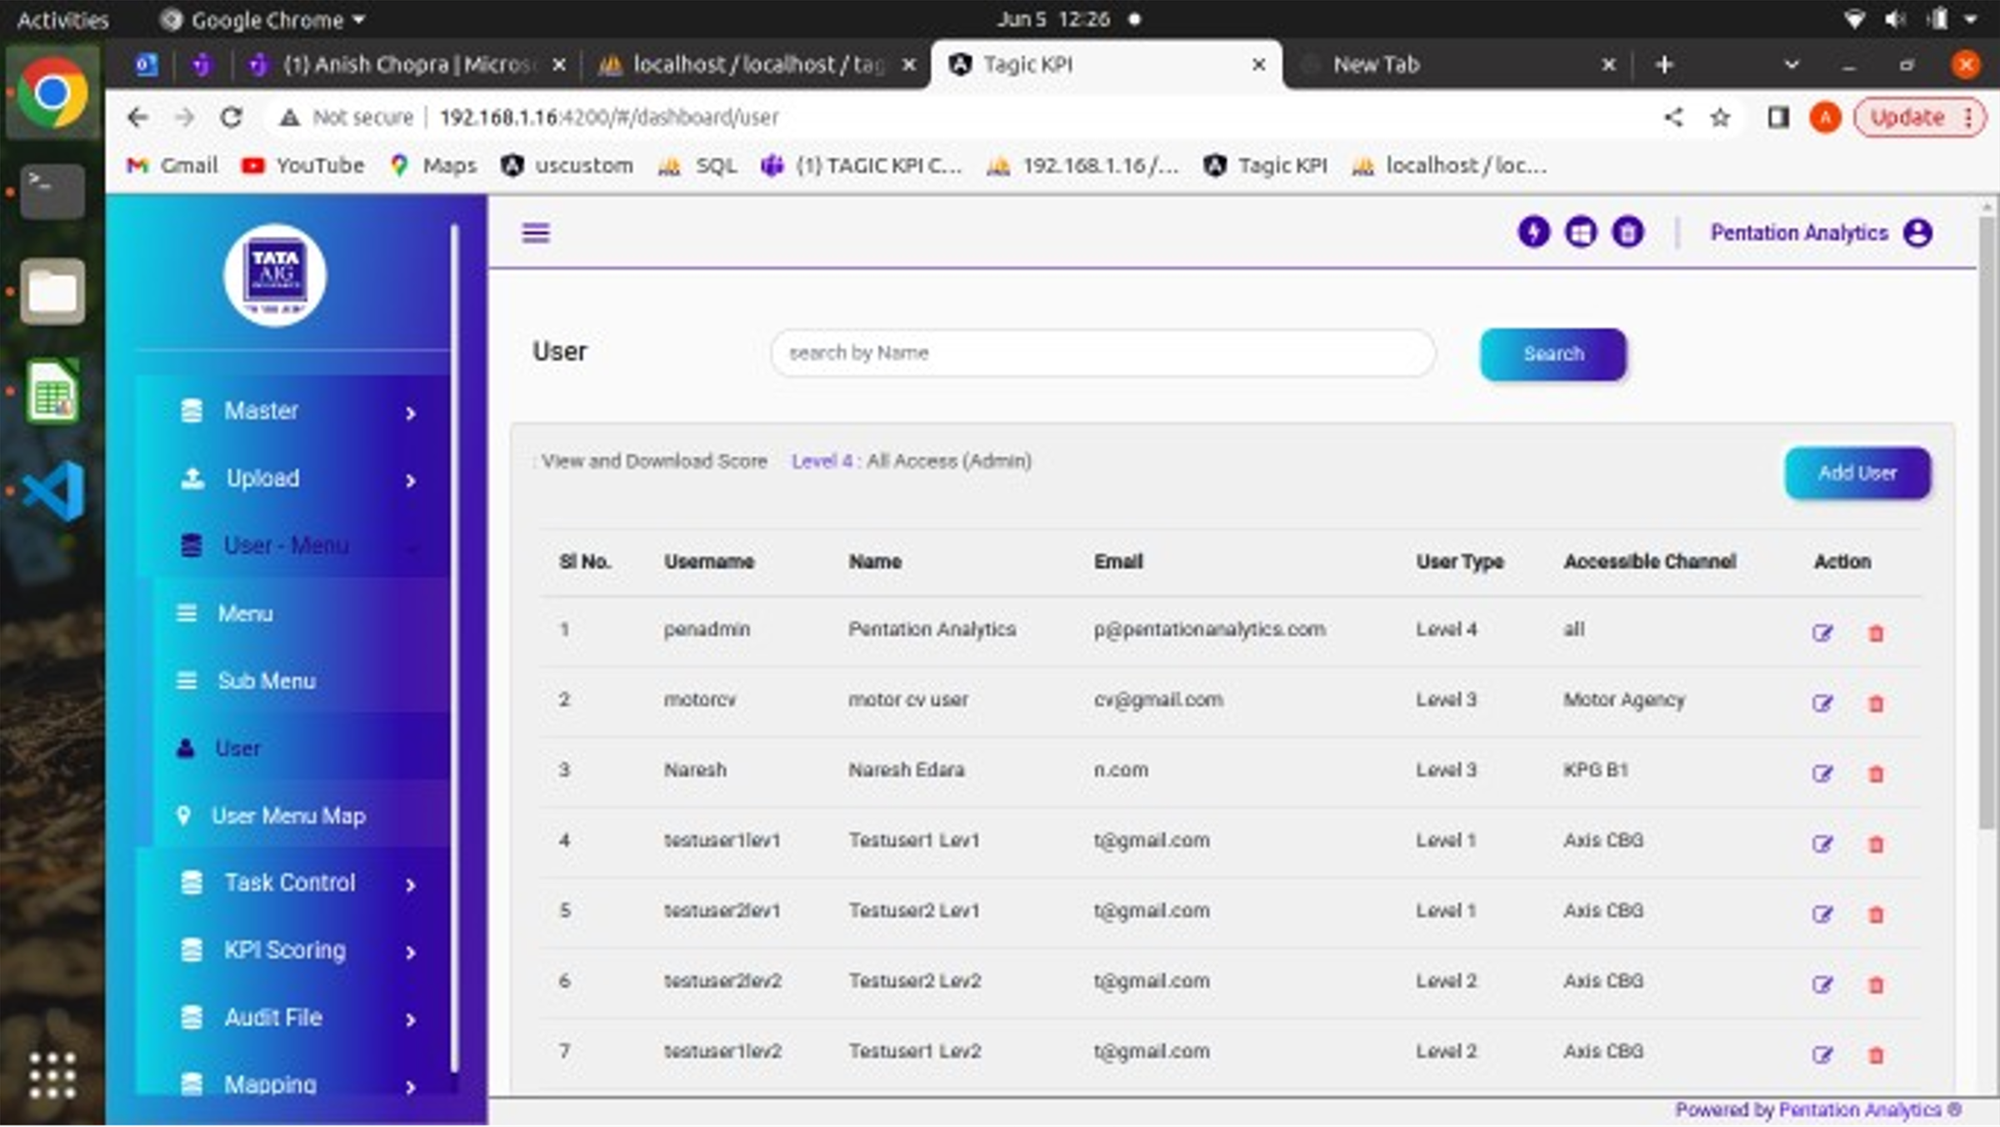
Figure 31: KPI User
Using Add User Button in the provided interface, admin users can create new user accounts by entering the required information such as username, password, email address, Channel, Level type. They can define the user's role, access permissions, and other specific settings as necessary.
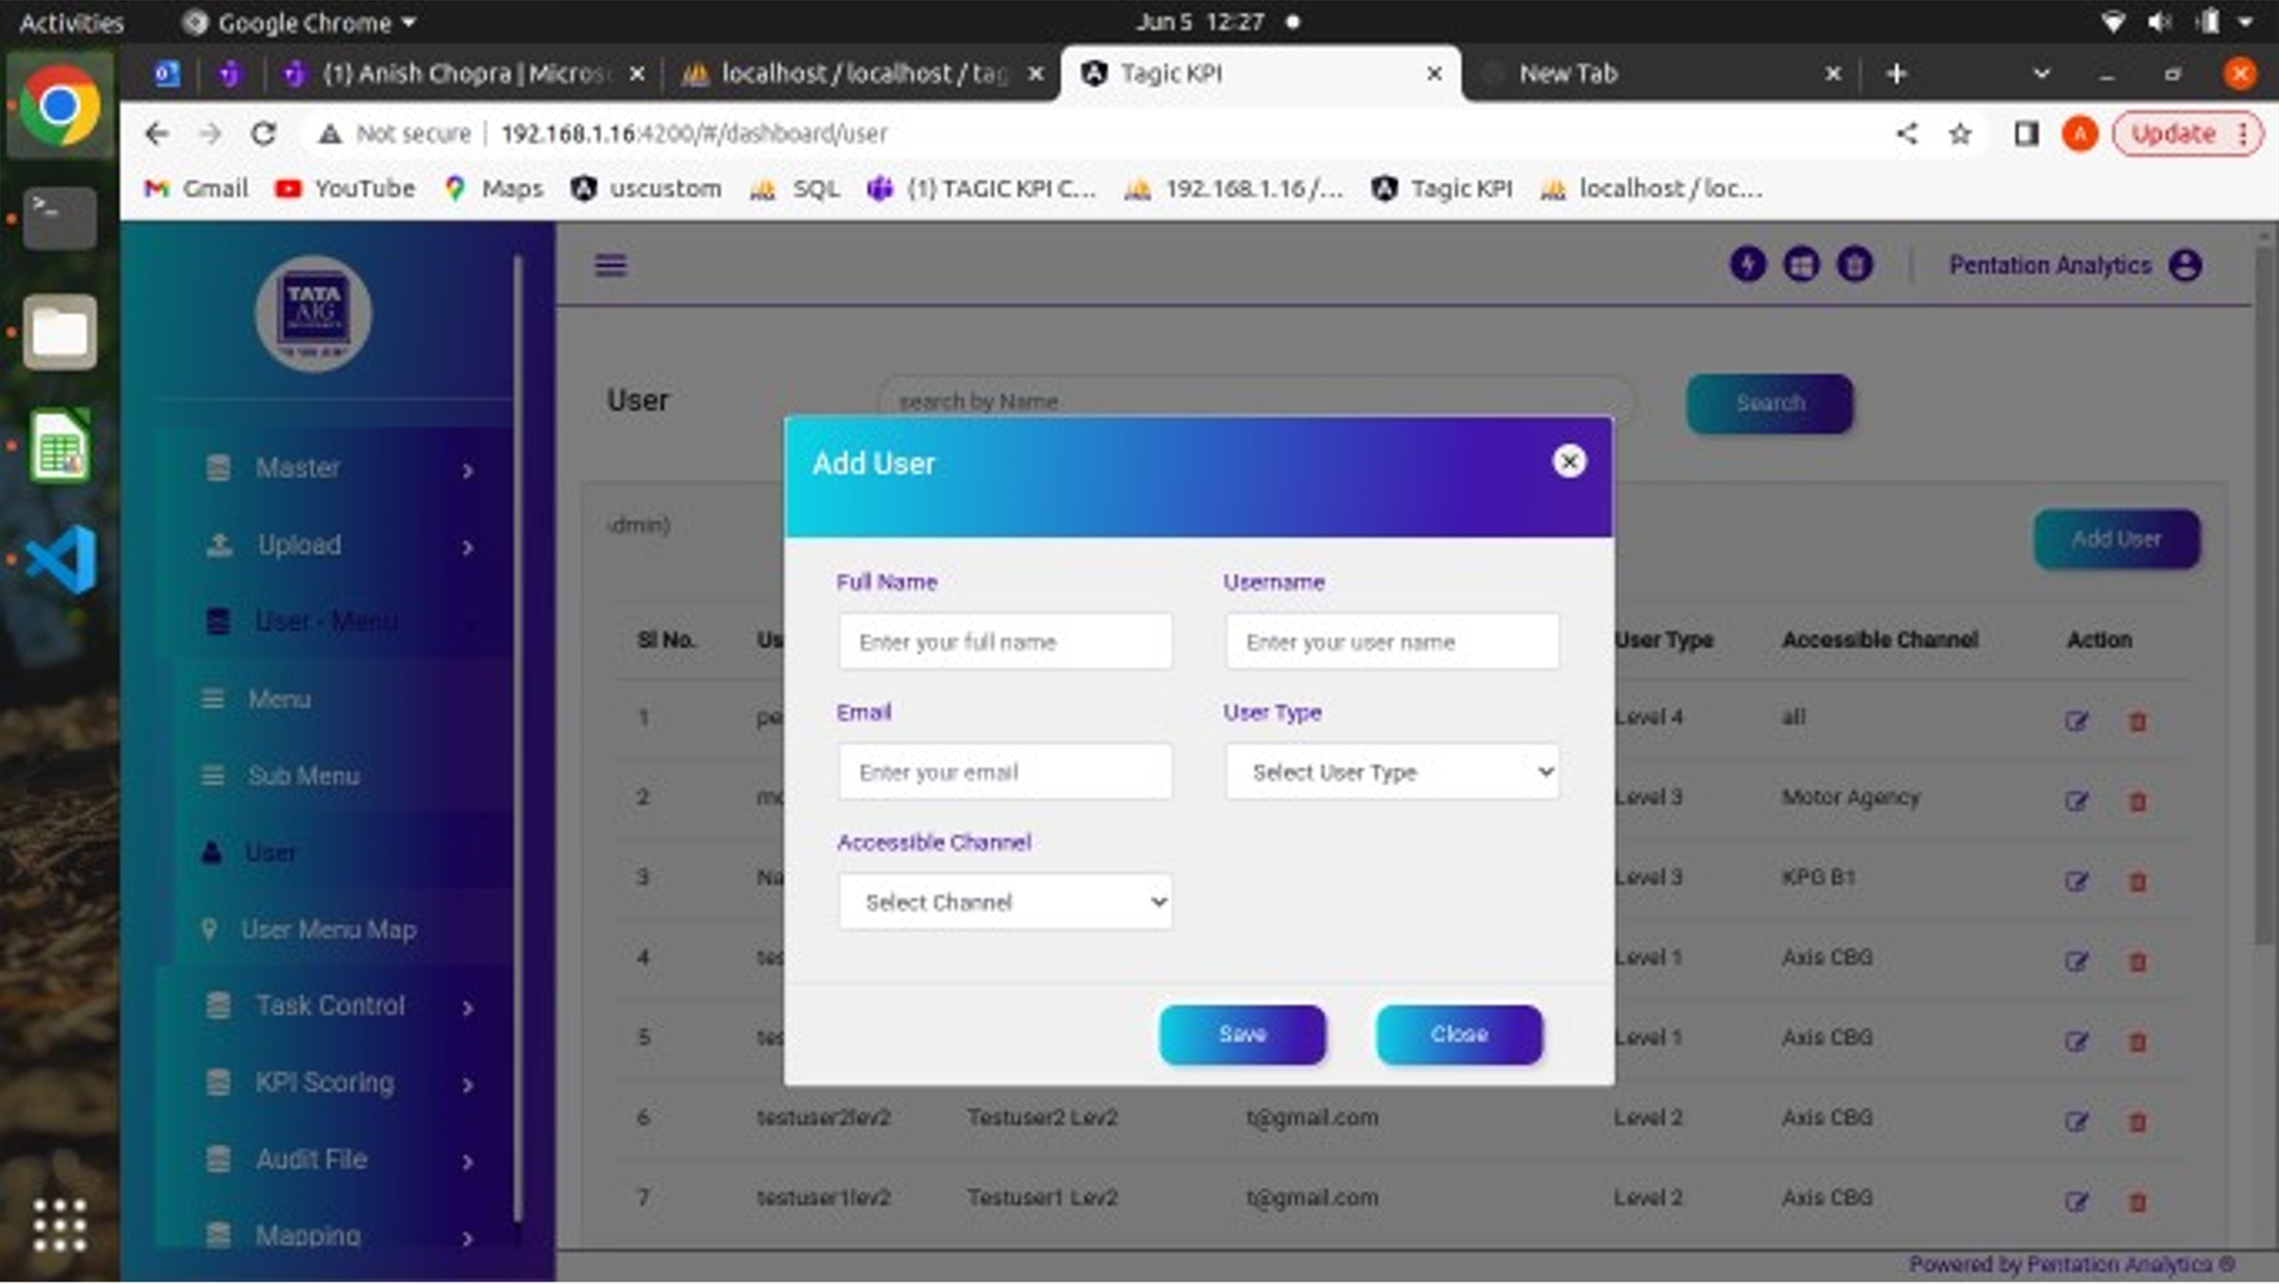
Figure 32: Add User
In addition to creating new user accounts, admin users can also edit existing user accounts. They can modify user information, any other necessary changes to the user's account settings.
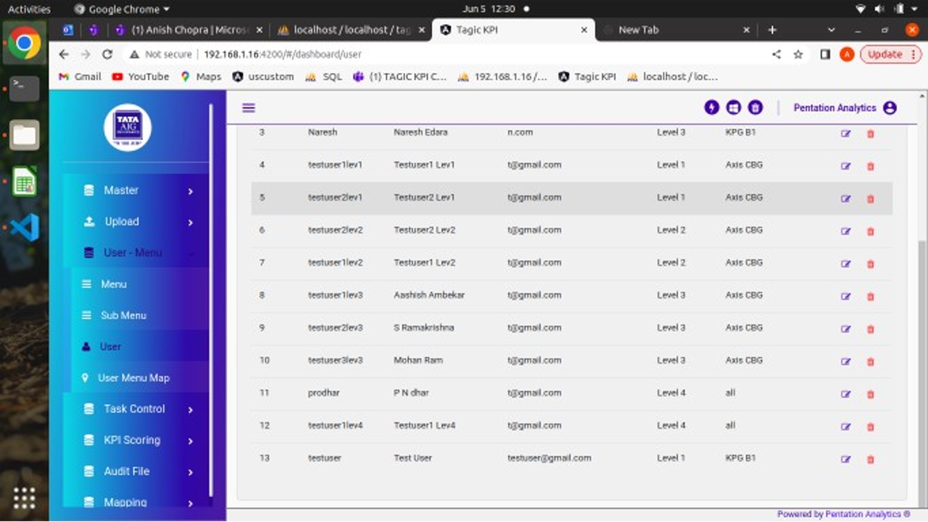
Figure 33: Edit User

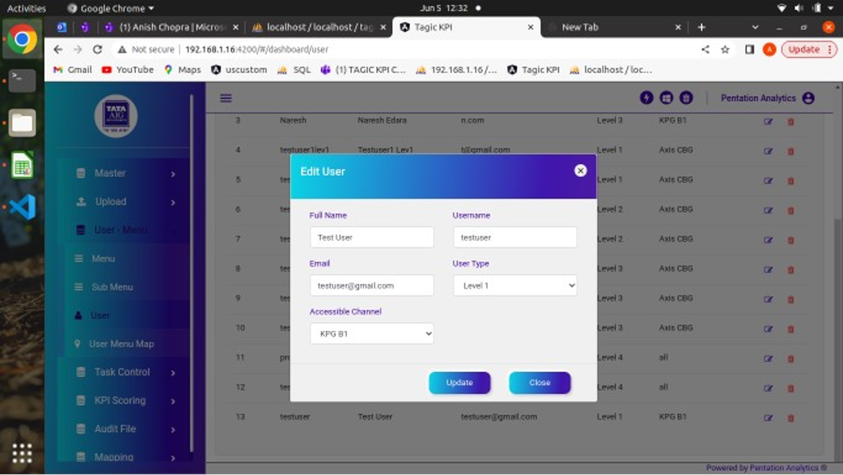
Figure 34: Edit/Update User

